### 

### AUTOMATED NETWORK REQUEST MANAGEMENT IN SERVICENOW

INTRODUCTION:

Project Title : Automated Network Request Management In Servicenow

PROJECT OVERVIEW:

The Automated Network Request Management in ServiceNow project that automates the handling of network service requests—like new connections, upgrades, and troubleshooting—using ServiceNow workflows. Requests are captured, categorized, and routed to the right team instantly, with real-time updates and SLA tracking. The solution reduces delays, minimizes errors, and improves transparency, making network support faster and more efficient.

OBJECTIVES:

* Improve User Experience – Offer a user-friendly self-service portal for employees to submit and track their network requests.
* Enable Better Reporting– Generate data-driven insights to monitor performance, identify bottlenecks, and improve service quality.
* Automate Request Handling – Reduce human intervention by using ServiceNow workflows to process requests from submission to closure.
* Standardize Processes – Shorten the time taken to approve and fulfill network-related requests.
* Improve Efficiency –Automate the submission, approval, and fulfillment process for network-related requests to reduce turnaround time.
* Enhance Transparency –Provide real-time tracking and status updates for both requesters and technicians.
* Reduce Manual Workload–Ensure all network requests follow consistent workflows, reducing errors and miscommunication.
* Improve Service Delivery Speed – Minimize repetitive administrative tasks for IT teams through automation.
* Ensure Data Accuracy – Use dynamic forms with conditional logic to capture all necessary details without missing information.
* Enhance Transparency – Allow requesters to track their request status in real-time through the portal.

PROBLEM STATEMENT:

In many organizations, network-related service requests—such as new connection setups, bandwidth upgrades, or VPN access—are still handled through manual, email-based, or paper-based processes. These outdated methods often lead to:

* Delays in request processing due to dependency on manual approvals.
* Lack of transparency for requesters, who have no real-time visibility into the status of their requests.
* High error rates caused by incomplete or unclear request information.
* Inconsistent workflows, with steps varying from one request to another.
* Inefficient communication between requesters, approvers, and technicians, leading to misalignment and rework.
* As a result, IT teams spend significant time on repetitive administrative tasks rather than focusing on critical technical issues. This not only reduces productivity but also impacts user satisfaction and delays business operations.

PROPOSED SOLUTION:

The proposed solution is to design and implement an automated, end-to-end network request management system using the ServiceNow platform.

Key Components of the Solution:

* Service Catalog Integration – Create custom catalog items for different network services such as new connections, bandwidth upgrades, VPN setups, and access modifications.
* Dynamic Request Forms – Implement forms with conditional logic to capture precise request details based on the service type, ensuring accuracy and completeness.
* Workflow Automation – Configure ServiceNow’s workflow engine to validate request details, assign them to the appropriate approvers, and automatically route approved requests to the responsible fulfillment teams.
* Real-Time Notifications – Enable automated email/SMS notifications to keep requesters, approvers, and technicians updated at each stage.
* Tracking & Reporting – Provide dashboards and reports for IT managers to monitor request volumes, SLA compliance, and team performance.

KEY FEATURES:

* Service Catalog :

Centralized catalog with dedicated items for network-related requests (e.g., new connection, bandwidth upgrade, VPN setup).

Easy access for employees via a self-service portal.

* Dynamic Forms:

Forms adapt based on the type of request.

Ensures accurate data capture and reduces follow-up queries.

* Workflow Engine:

Automates request validation, approval routing, and task assignment.

Supports multi-level approvals based on predefined rules.

* Notifications:

Automated email/SMS updates at each stage of the request lifecycle. Keeps requesters, approvers, and technicians informed in real time.

WORKFLOW PROCESS:

The automated network request management workflow in ServiceNow follows a step-by-step process to ensure accuracy, speed, and transparency from request submission to closure.

Step 1 – Request Submission

The requester logs in to the ServiceNow Self-Service Portal.

Step 2 – Request Validation

The system validates mandatory fields using conditional logic.Any missing or incorrect information is flagged before submission.

Step 3 – Approval Routing

The workflow engine automatically identifies the approver(s) based on predefined rules.Requests requiring multiple approvals follow a sequential or parallel process depending on the configuration.

Step 4 – Task Assignment

Once approved, the request is routed to the appropriate IT/network team.ServiceNow automatically creates fulfillment tasks and assigns them to the correct technician or team.

Step 5 – Real-Time Notifications

Requesters, approvers, and technicians receive email/SMS updates at each stage.Status changes (e.g., Approved, In Progress, Completed) are instantly visible in the portal.

Step 6 – Request Fulfillment

The assigned team completes the request as per the service requirements.Updates progress in ServiceNow for real-time tracking.

USECASES:

Use Case Table: Automated Network Request Management in ServiceNow

| Category | Details |
| --- | --- |
| Use Case Name | Automated Network Request Management |
| Business Objective | Streamline and automate network-related service requests to improve efficiency, accuracy, and compliance |
| Actors Involved | End Users, Network Administrators, ServiceNow Admins, Approvers |
| Entry Point | ServiceNow Service Catalog |
| Request Types | VPN Access, Firewall Rule Change, DNS Update, IP Allocation, Port Activation |
| Automation Components | ServiceNow Workflows, Business Rules, API Integrations with Network Tools |
| Process Steps | 1. Submit request via catalog 2. Validate inputs 3. Route for approval 4. Execute via API 5. Notify user |
| Integrated Systems | Cisco DNA Center, Infoblox, Palo Alto Networks, VPN Gateway, Network Switches |
| Key Features | Auto-validation, Dynamic approvals, Real-time status updates, Audit logging |
| Benefits | Faster turnaround, Reduced errors, Improved SLA compliance, Enhanced visibility |
| KPIs Tracked | Request volume, Fulfillment time, SLA adherence, Error rate, User satisfaction |
| Compliance Support | Full audit trail, Role-based access, Policy enforcement |

TESTING AND VALIDATION:

To ensure the reliability, accuracy, and security of the automated network request management system in ServiceNow, a comprehensive testing and validation strategy is essential. This process verifies that all components—from catalog items to backend integrations—function as intended and meet business requirements.

1. Catalog Item Functionality

Each network request type (e.g., VPN access, firewall changes) is represented by a ServiceNow catalog item. Testing ensures that:

* All required fields are present and validated.
* Conditional logic (e.g., showing fields based on selection) works correctly.
* Submissions trigger the correct workflows.
* 2. Workflow Execution

Workflows automate the lifecycle of a request. Validation includes:

* Ensuring tasks are created and assigned correctly.
* Verifying that business rules and conditions (e.g., auto-approval for low-risk requests) are applied.
* Confirming that escalations and SLA timers function as expected.

### 3. Approval Logic

Requests must be routed to the correct approvers based on type, department, and risk level. Testing involves:

* Simulating requests from different user roles.
* Verifying dynamic approval paths.
* Ensuring fallback or auto-approval logic works when applicable.

### 4. API Integration

ServiceNow integrates with network tools (e.g., Infoblox, Palo Alto, Cisco DNA Center) to automate configuration changes. Validation includes:

* Testing API calls for success and failure scenarios.
* Ensuring correct data is passed and changes are applied.
* Monitoring logs for response codes and error handling.

### 5. Error Handling

Robust error handling ensures the system responds gracefully to issues. Testing includes:

* Submitting invalid data.
* Simulating API failures or timeouts.
* Verifying that users receive meaningful error messages and that fallback workflows are triggered.

### 6. Notifications

Users should be kept informed throughout the request lifecycle. Validation includes:

* Testing email and SMS notifications for accuracy and timing.
* Ensuring notification templates are clear and actionable.
* Confirming that updates reflect real-time status changes.

7. Audit Logging

All actions must be logged for compliance and traceability. Testing ensures:

* Every request and change is recorded.
* Logs are tamper-proof and accessible for audits.
* Role-based access to logs is enforced.

8. Performance Testing

To ensure scalability, performance testing simulates high volumes of requests. This helps identify:

* Bottlenecks in workflow execution or API calls.
* System response times under load.
* Opportunities for optimization.

9. Security Validation

Security testing confirms that sensitive data and system access are protected. This includes:

* Role-based access control validation.
* Penetration testing and vulnerability scans.
* Ensuring encryption and secure API communication.

10. User Acceptance Testing (UAT)

Final validation is performed by end users and stakeholders. This phase ensures:

* The solution meets business needs.
* The user experience is intuitive and efficient.
* Feedback is collected and incorporated before go-live.

PHOTHOS:

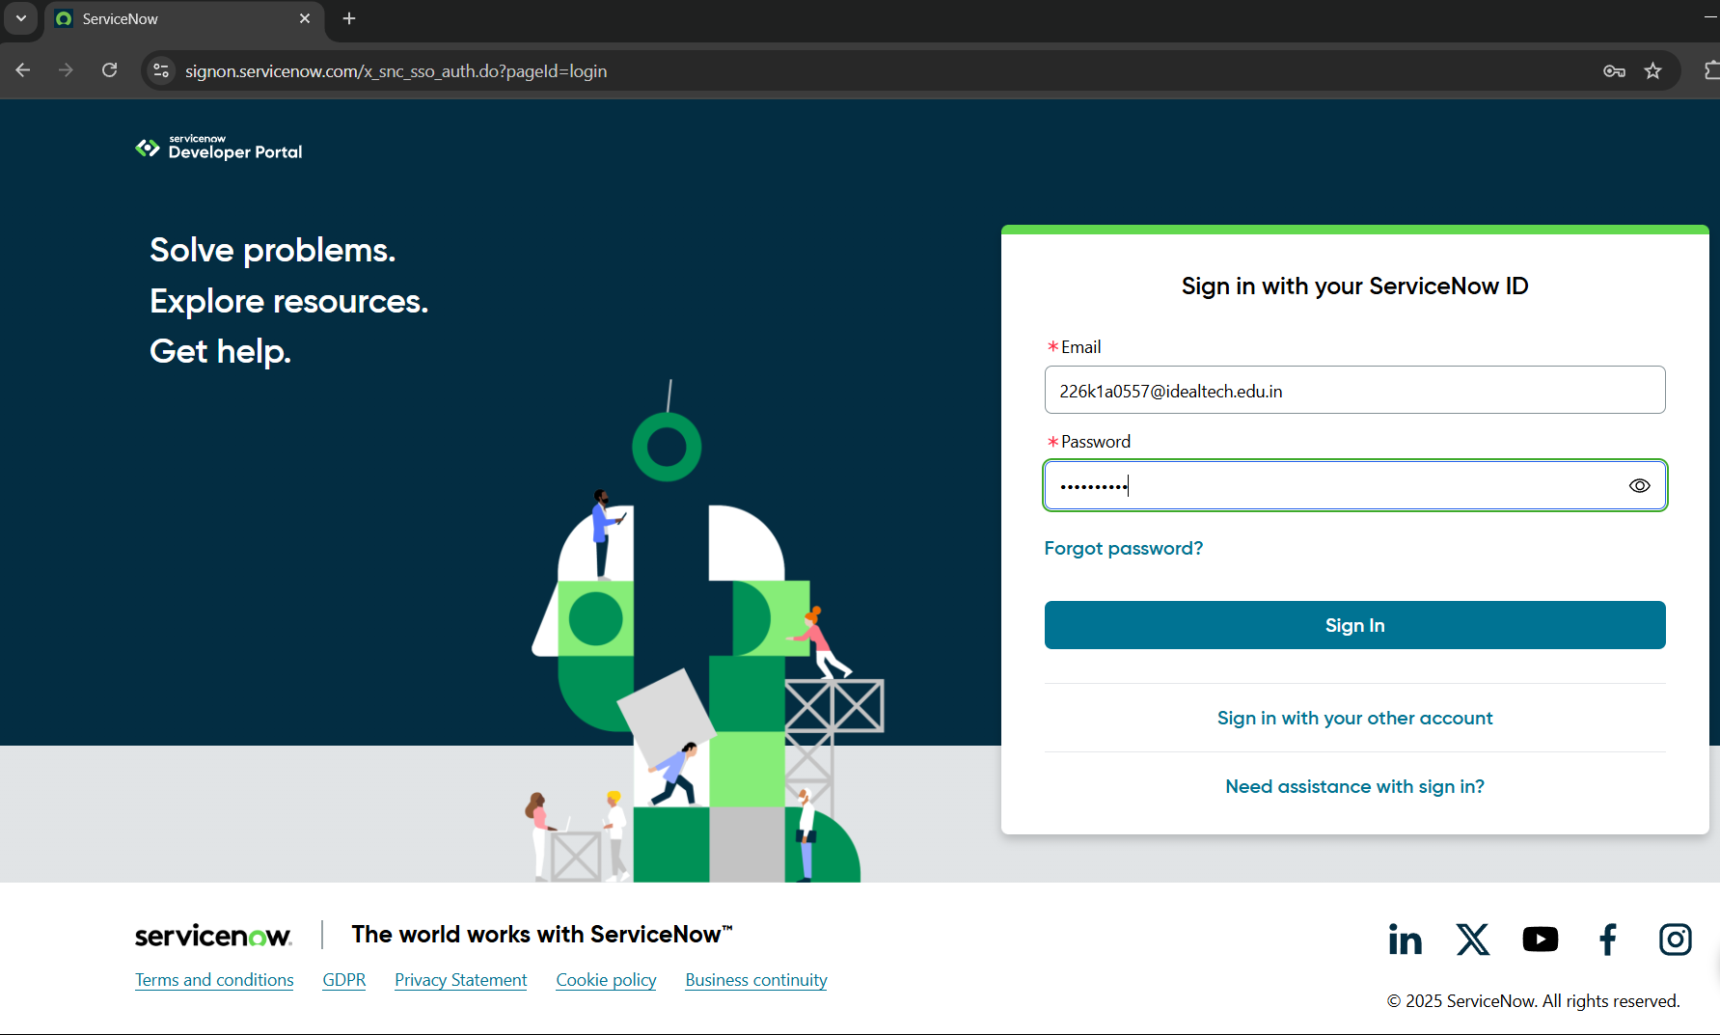

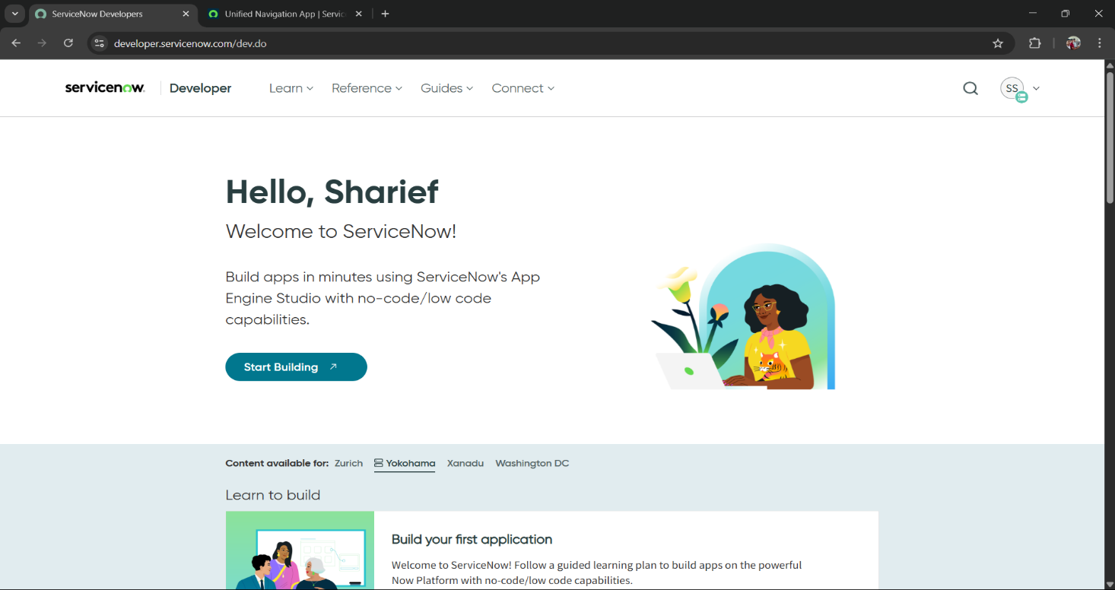

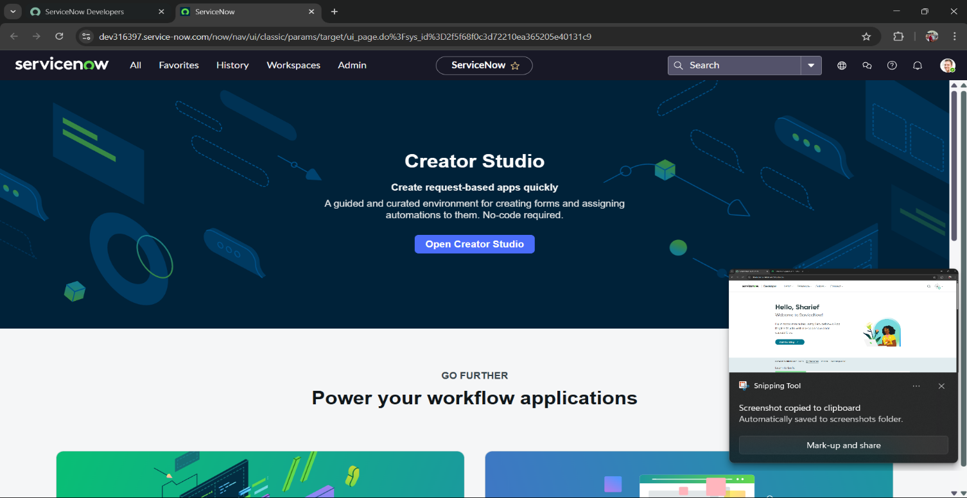

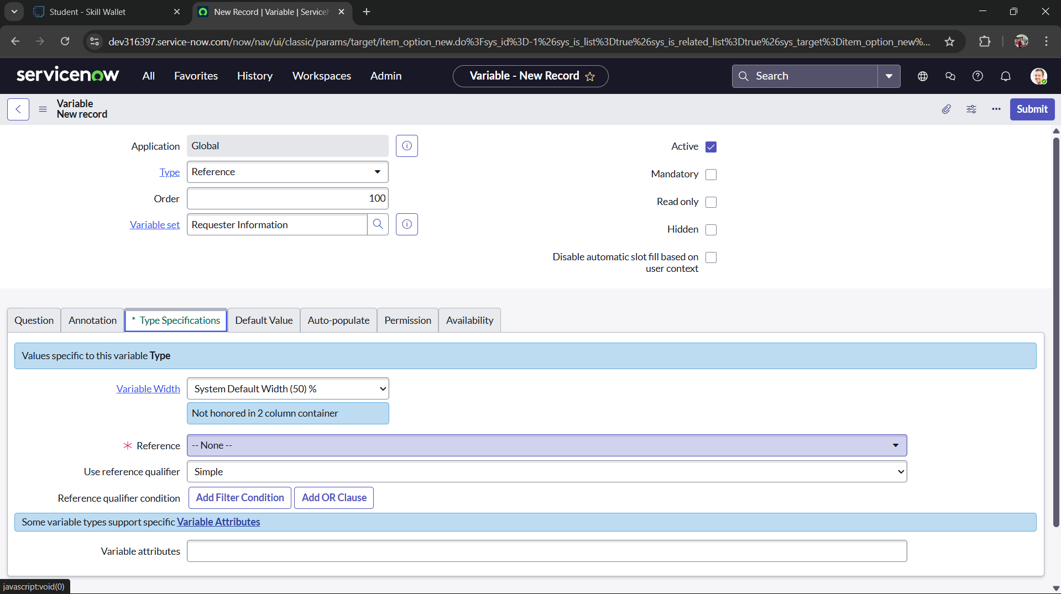

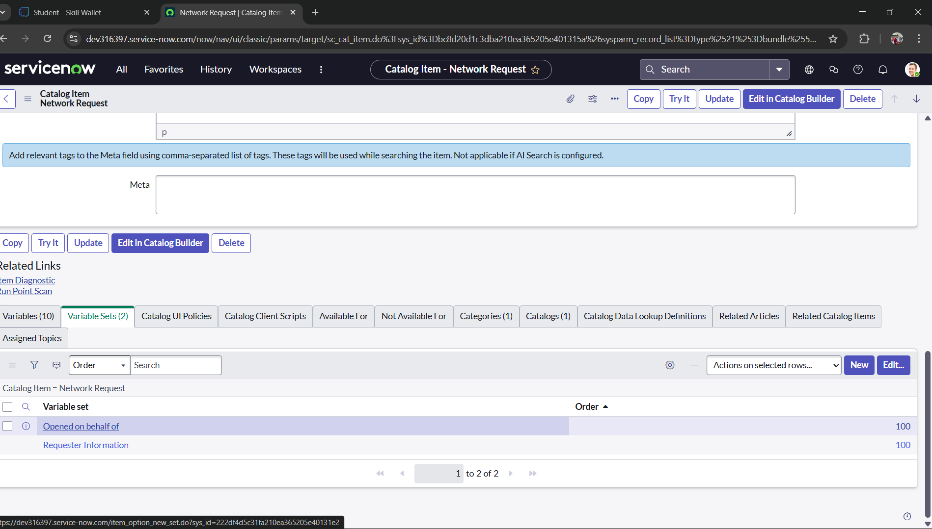

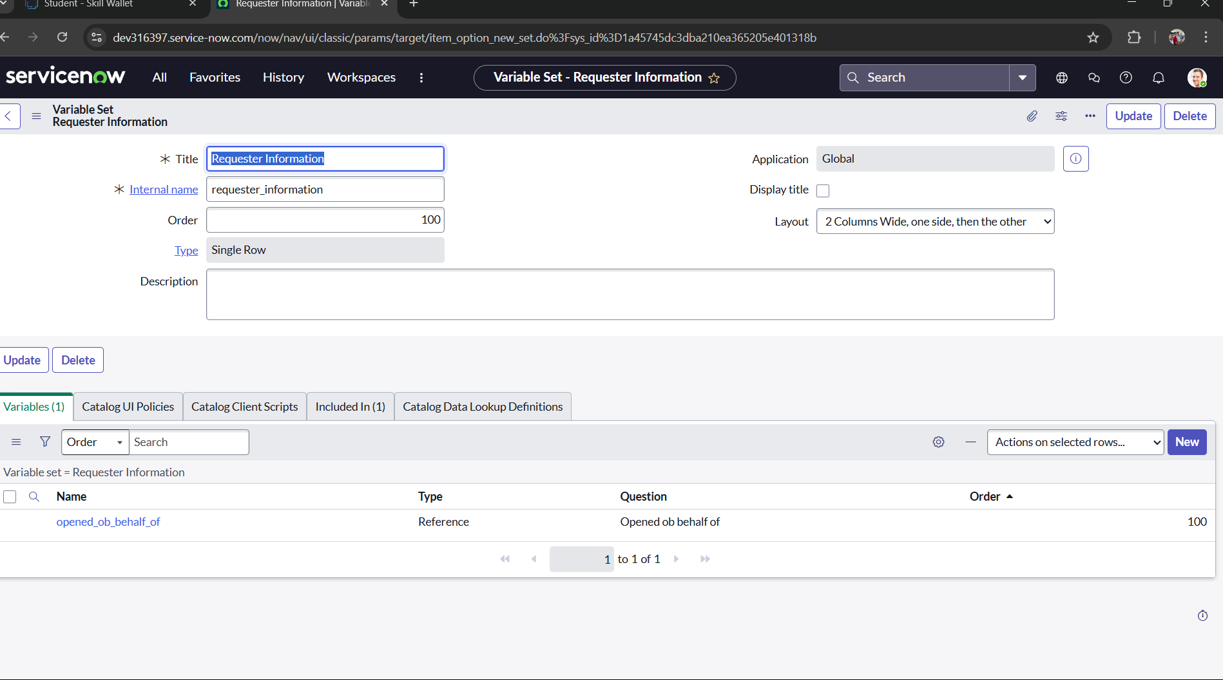

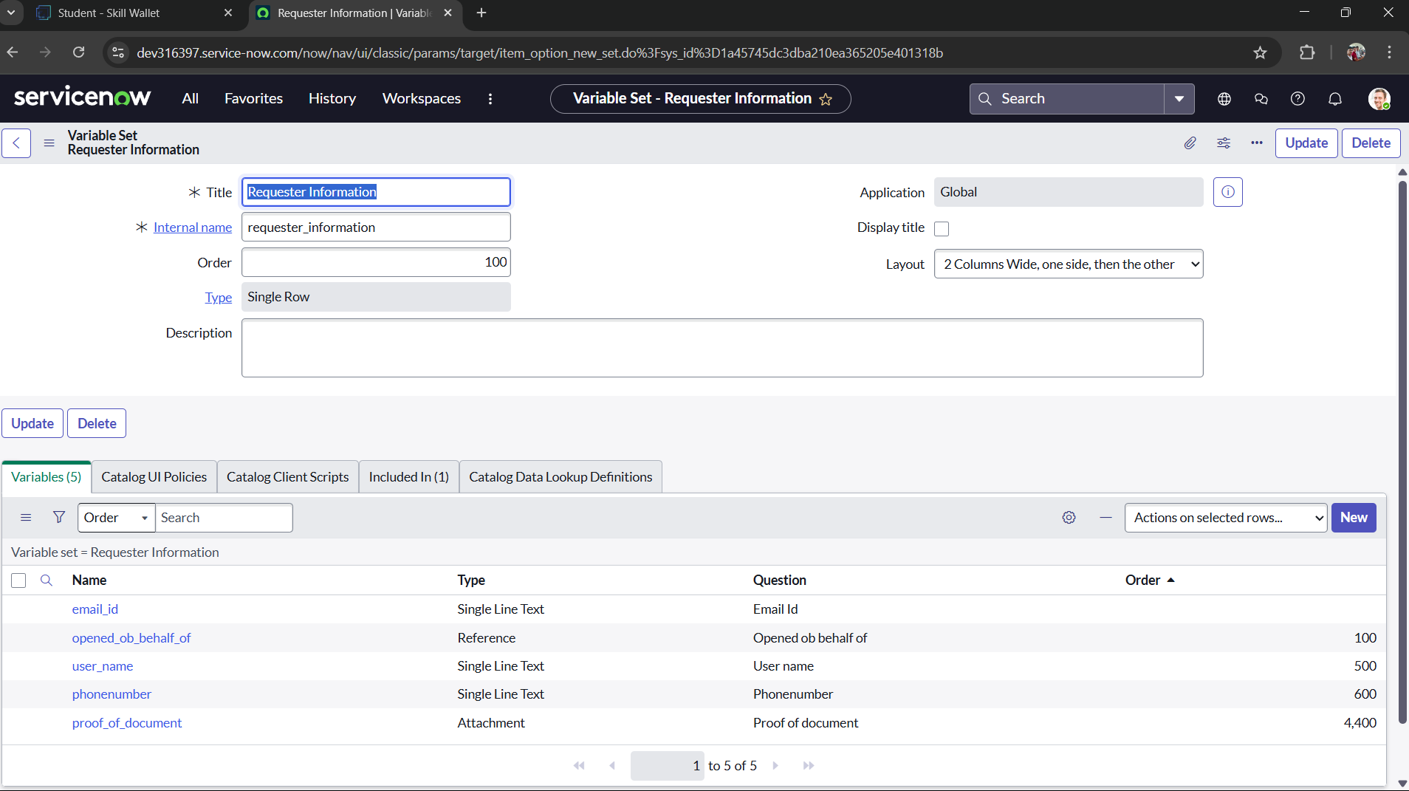

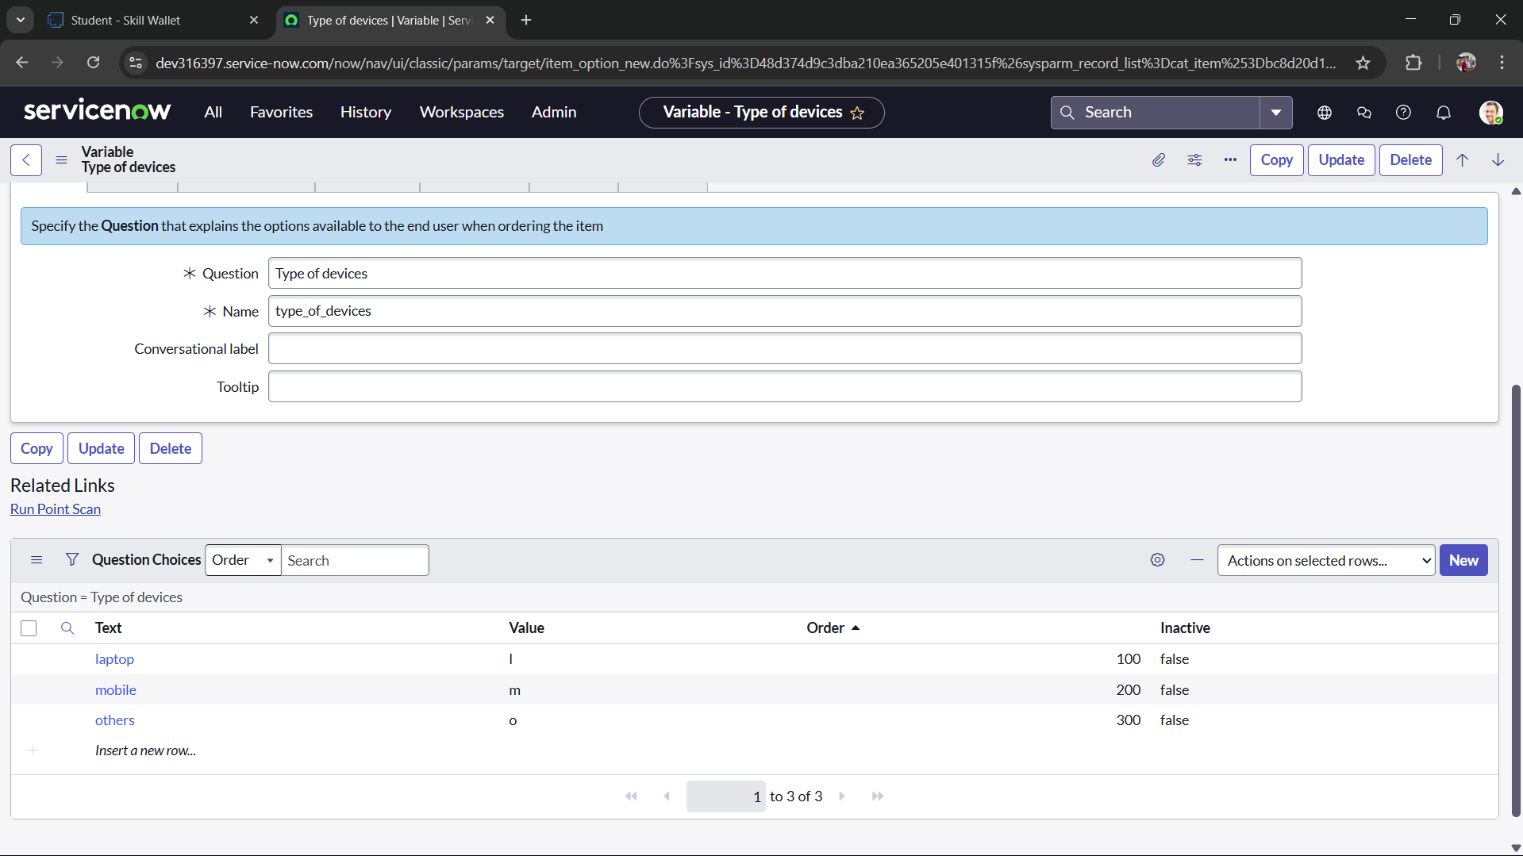

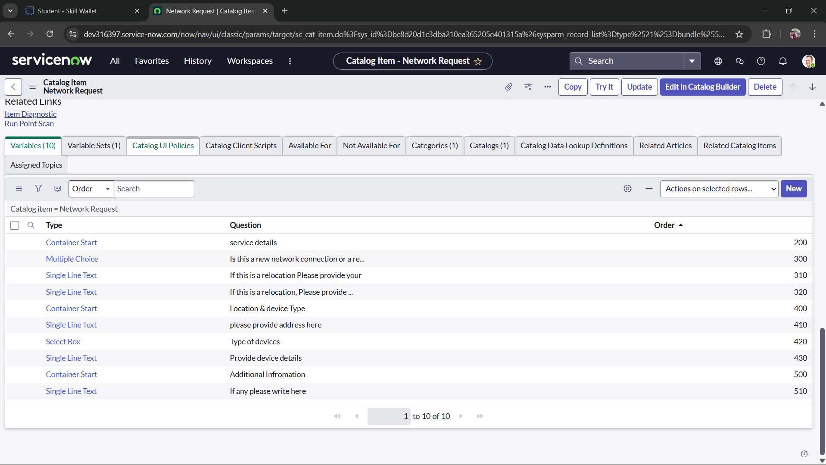

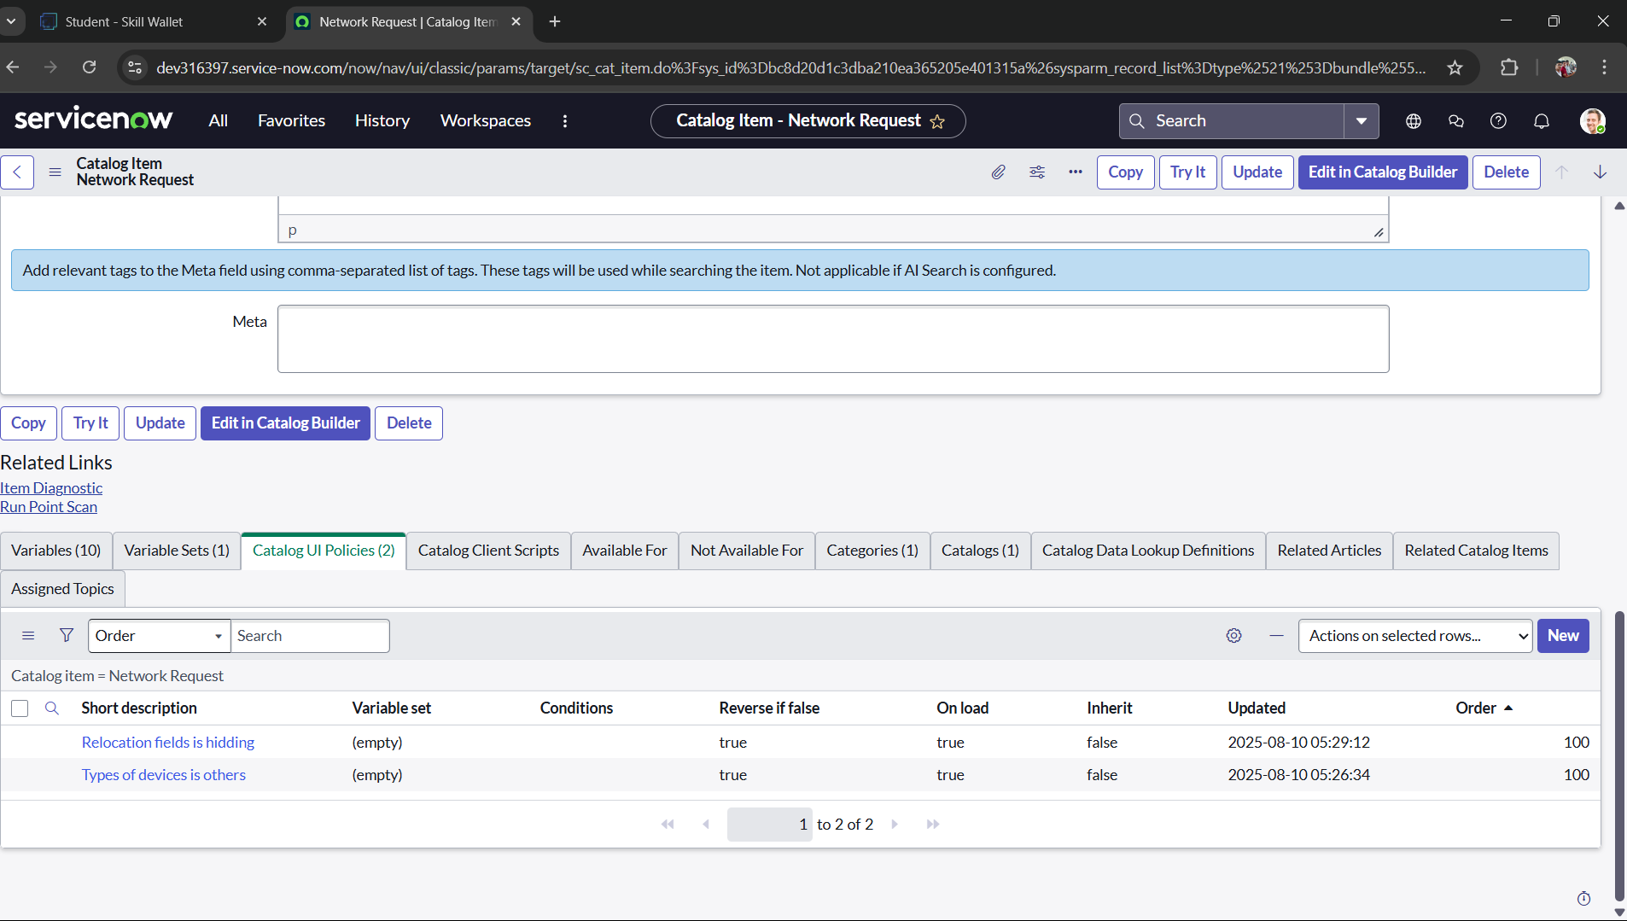

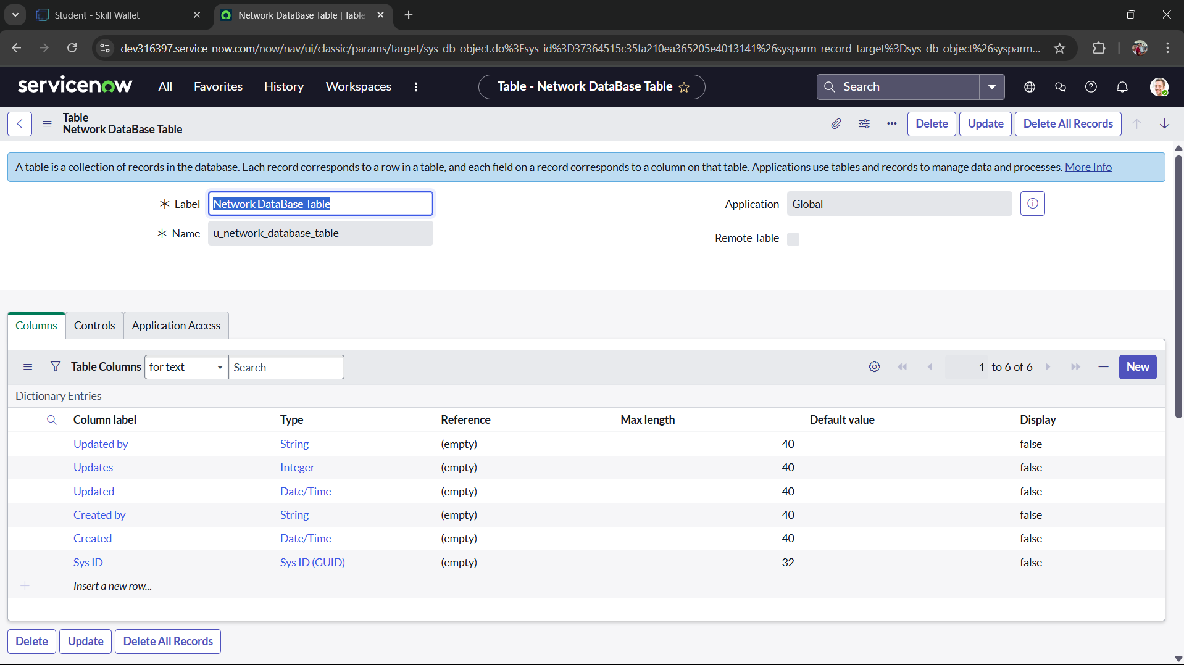

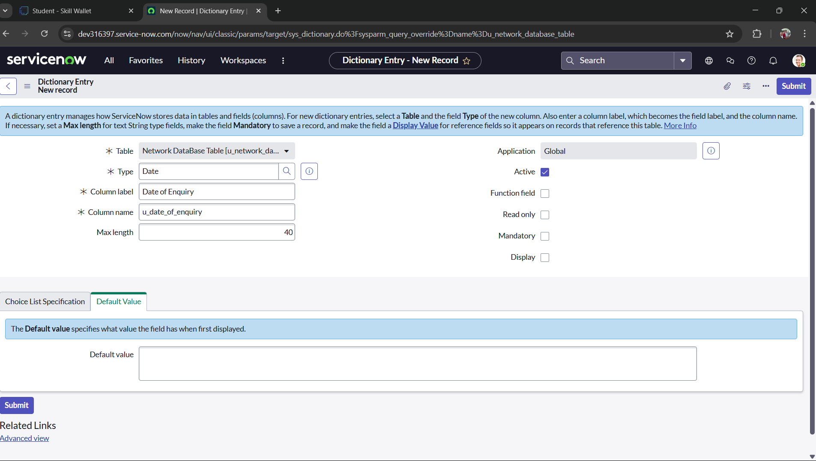

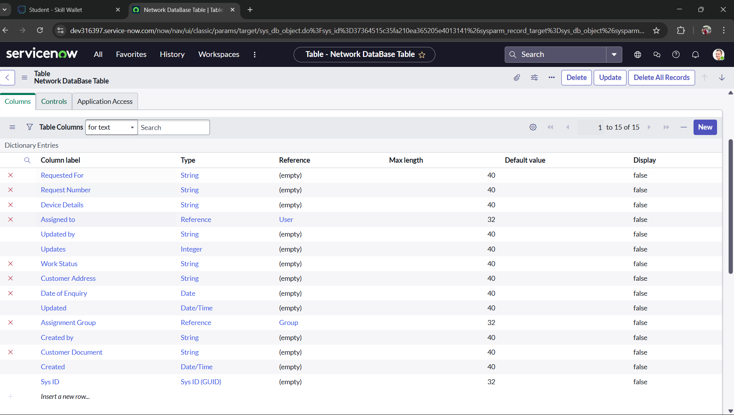

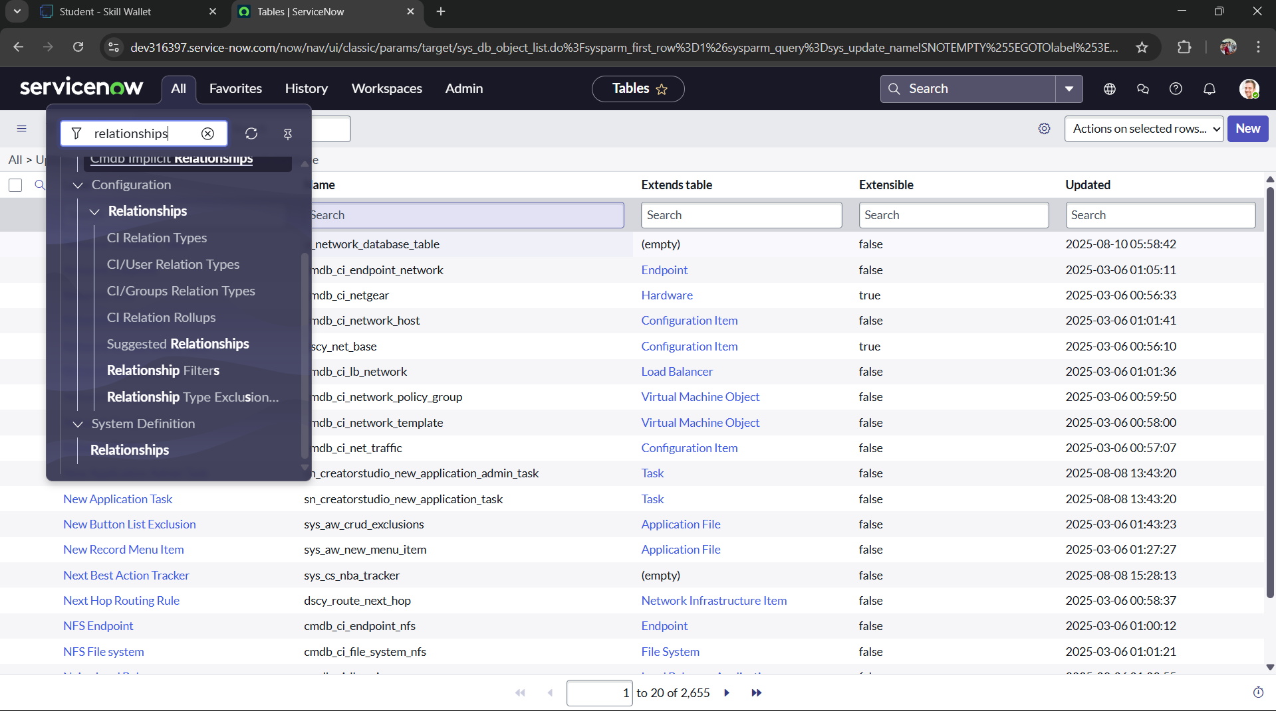

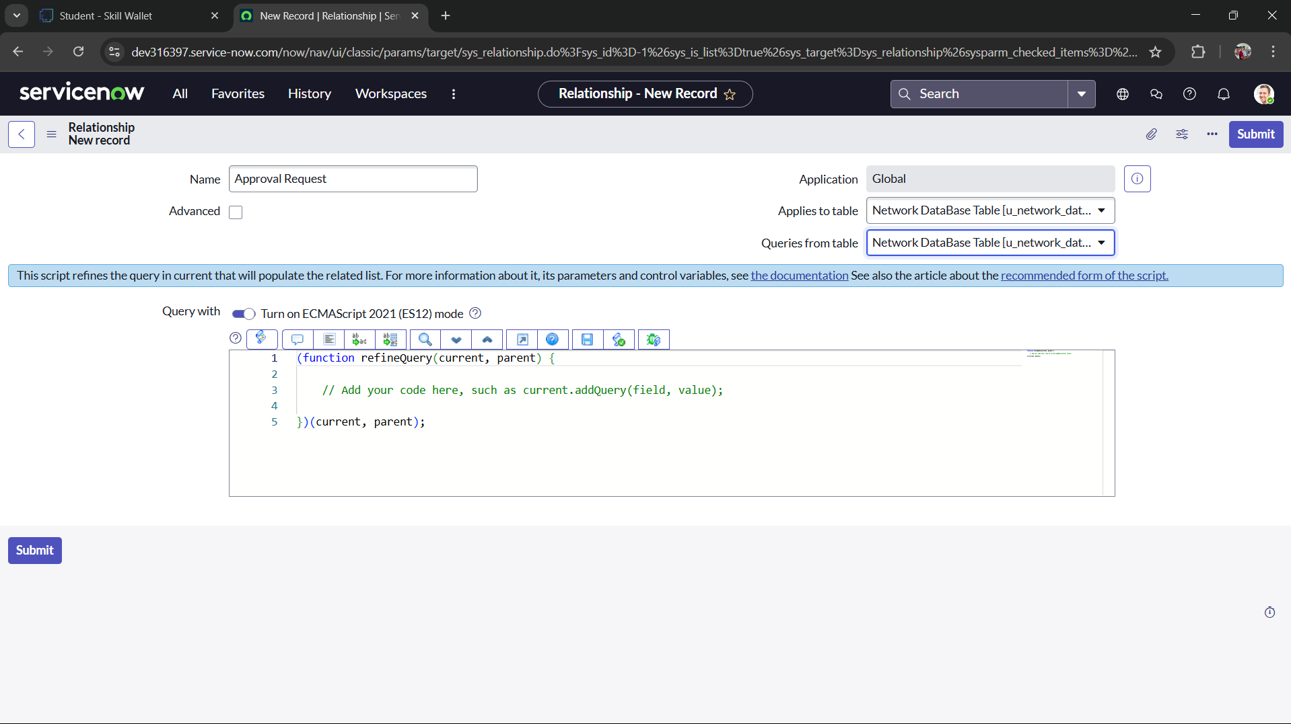

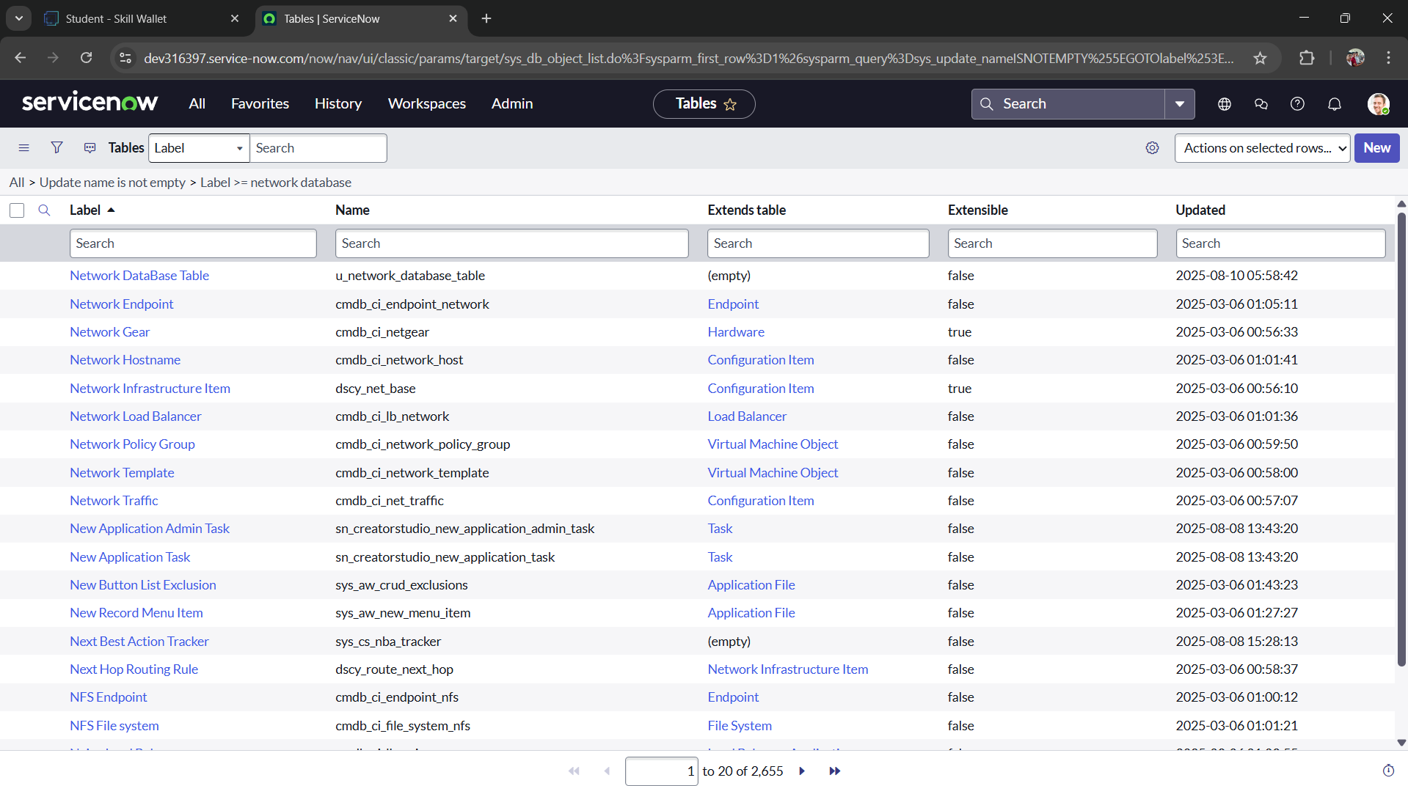

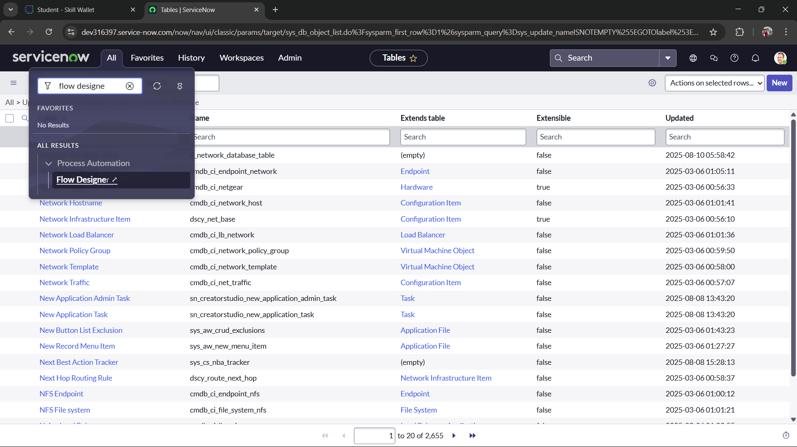

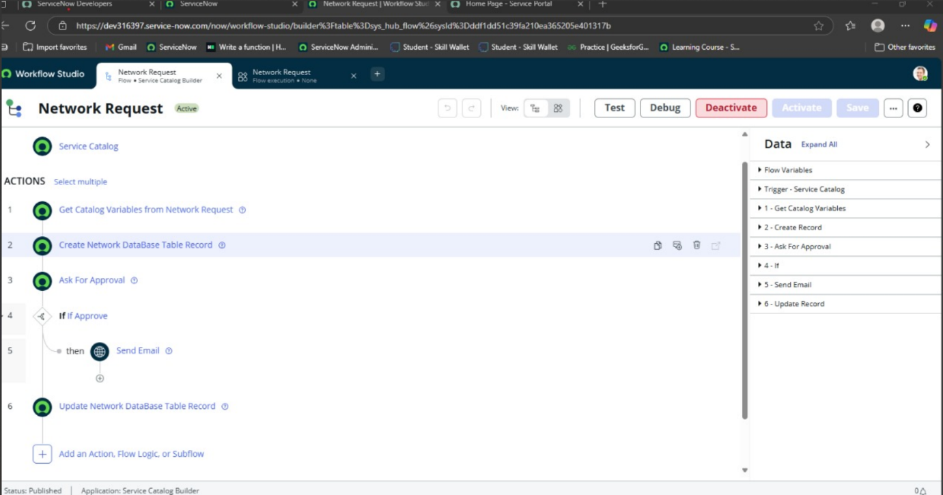

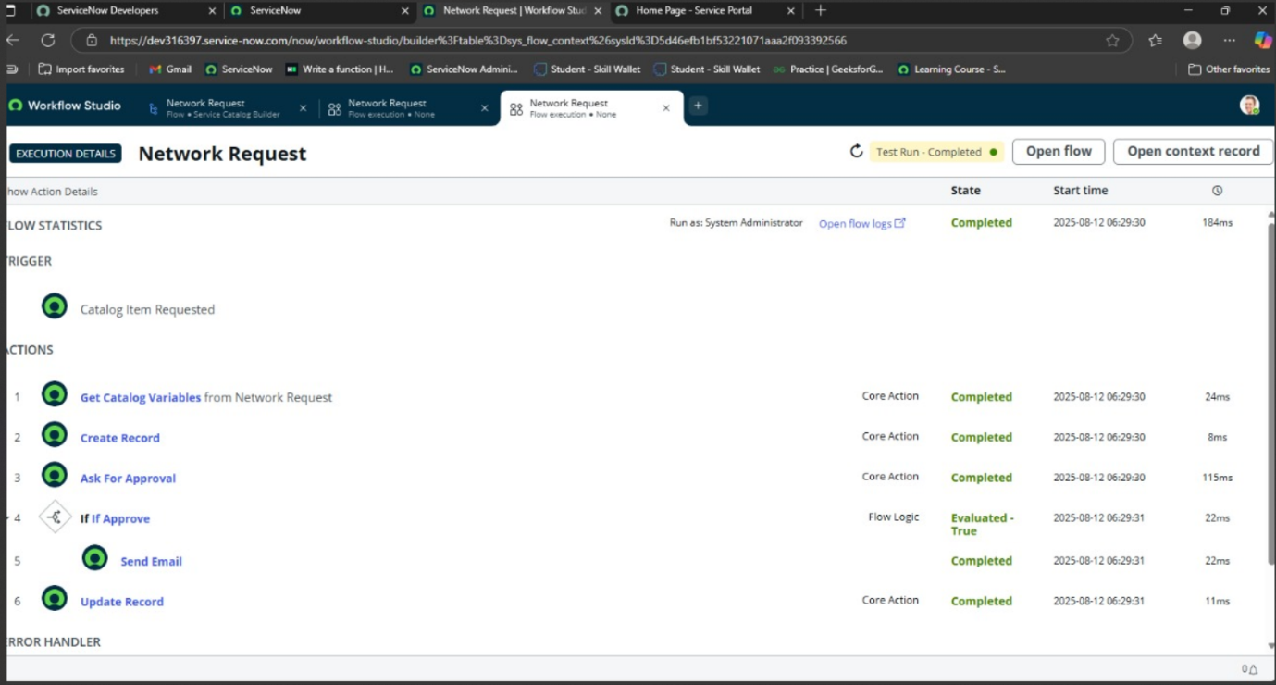

CONCLUSION

* Automating network request management within ServiceNow transforms a traditionally manual, error-prone process into a streamlined, efficient, and secure workflow. By leveraging ServiceNow’s catalog items, dynamic workflows, and integrations with network infrastructure tools, organizations can drastically reduce turnaround times, improve accuracy, and ensure compliance with IT policies
* Comprehensive testing and validation—spanning functionality, workflow logic, integrations, performance, and security—are critical to ensuring the solution is robust and production-ready. With successful implementation, IT teams gain better visibility, users experience faster service delivery, and the organization benefits from scalable, auditable, and policy-driven network operations.